RFLTools

Lesson 1: Grading a Curb Return

1. Define Alignments
   1. Horizontal Control

Commands Used:

* LINE
* FITSPIRAL
* GALIGN
* DALIGN
* MAKEENT
* WALIGNB
* RALIGNB
* RAB

Set your current layer and create your centerline control. For this lesson we’ll start with a simple alignment – Line-Spiral-Curve-Spiral-Tangent. Begin by drawing two centerline control lines:

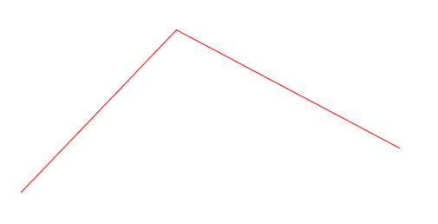

Next use FITSPIRAL to generate a Spiral-Curve-Spiral:



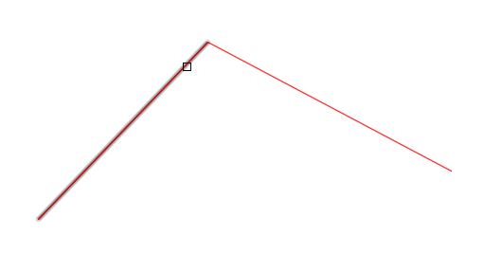



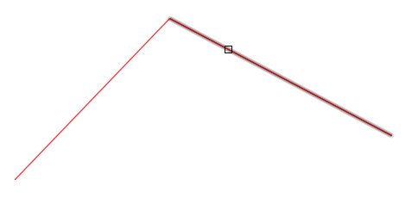

For my alignment I will use a 250m curve with 60m in and out spirals

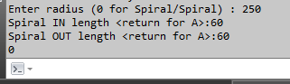

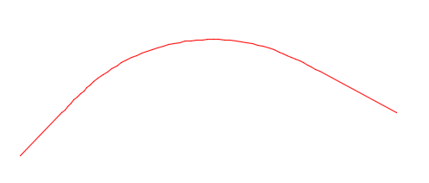

If you don’t have linework that looks similar to the above try again with longer/shorter tangents and/or a different deflection angle. You should have 5 entities which will define this horizontal control. Spirals are polylines with extended data information which specify the spiral start, end and PI.

Next define the alignment with GALIGN (GetAIGNment)



Snap to the end point at the beginning of your alignment

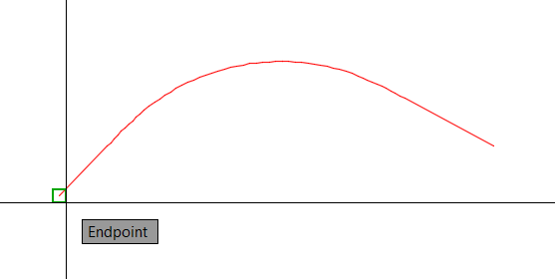

Enter the starting chainage (note to use numbers only – no ‘+’ needed). For my alignment I will use 1000.

Next GALIGN is looking for you to select a single polyline or press return to select individual entities. If you’re alignment only contains lines and arcs it can be created as a single polyline – this may be useful as it may be easier as you can offset, edit, join etc. For alignments that contain spirals its necessary to have them defined as individual entities (as in this example).

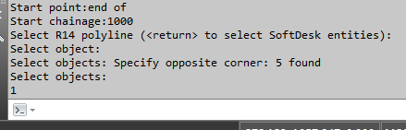

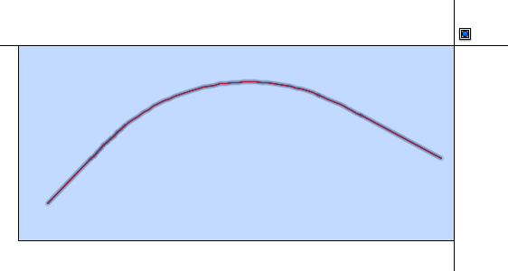

If all went well you now have an alignment stored in memory. Probably the easiest way to test is to erase your alignment and draw it back with DALIGN (DrawALIGNment). If you don’t get back the entities then undo until the entities reappear and try again. Note that I find it useful to issue ‘UNDO’ ‘MARK’ to place mark points – you can then issue ‘UNDO’ ‘BACK’ to get to specific points.

With the alignment defined I usually like to store it. There are a number of ways to do this but my preferred method is to use alignment blocks (block name: RFLALIGN). Alignment blocks are custom blocks which hold alignment information in a long list of attributes.

If you don’t already have this block defined in your drawing you can create one by using MAKEENT



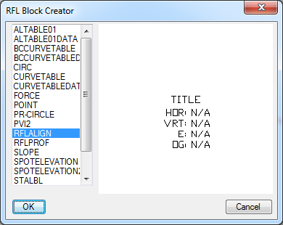

Now that it is defined you can insert it into your drawing. You can move/scale as you wish – I prefer to place these near the beginning of the alignment

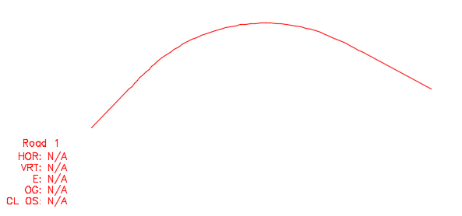

Give the alignment a name but always leave the other attributes alone.

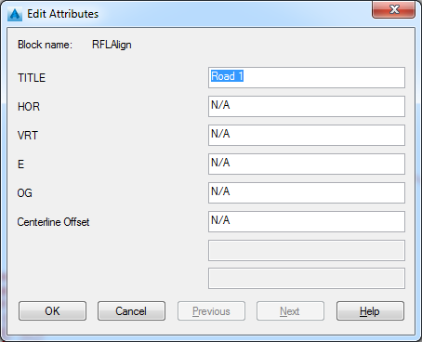

With the block in the drawing we can write the alignment to this block by using the command WALIGNB (WriteALIGNmentBlock)



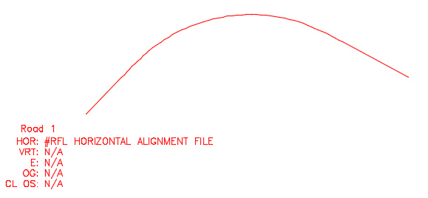

If you ATTEDIT the block you’ll see all the alignment details inserted as HOR attributes (again, don’t change anything except for the name).

You now have the first road defined and stored.

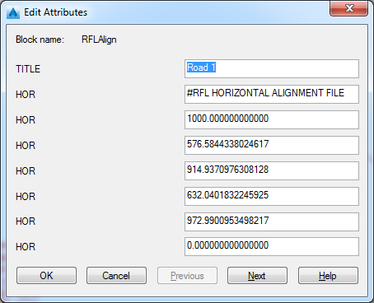

Now do the same on a crossing road. For this lesson I will use a single 500 m arc crossing the arc in Road 1 and start it’s chainage at 2000

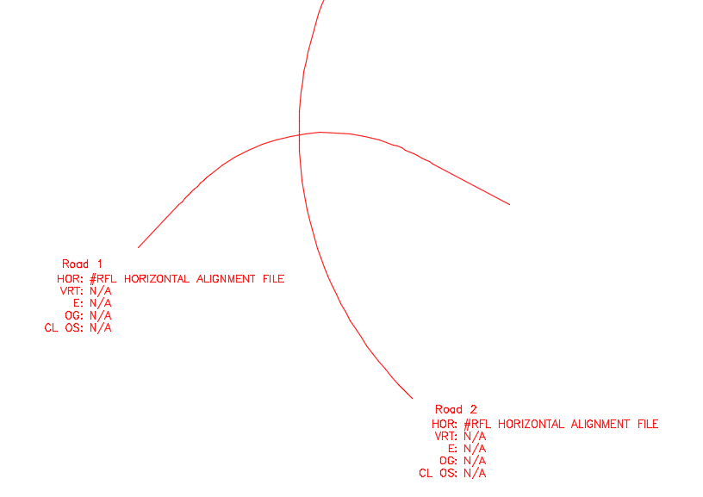

You can quickly change which alignment you have loaded in memory by using RALIGNB (ReadALIGNmentBlock) and selecting the alignment definition block. Even simpler is to use RAB (ReadAlignmentBlock) which will load all the alignments (horizontal, vertical, superelevation, etc) defined in that block.

* 1. Profile Control

Commands Used:

* MAKEENT
* (RFL:PROFDEF)
* (RFL:VP)
* LINE
* VCURVE
* GPROF
* DPROF
* WPROFB

To create a profile you need to know how it is situated in your drawing. The profile location (base point, base station, base elevation, vertical exaggeration, etc) is defined by inserting a block (RFLPROF) onto the drawing and setting location details. If the block is not defined use MAKEENT to create it

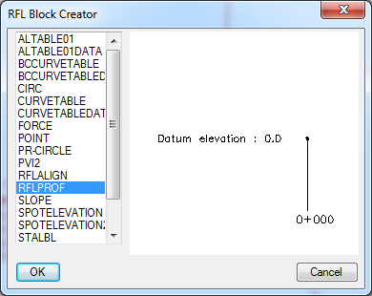

Insert this block in a location where it will not conflict with the alignments. Moving it later is very simple (just use the MOVE command)

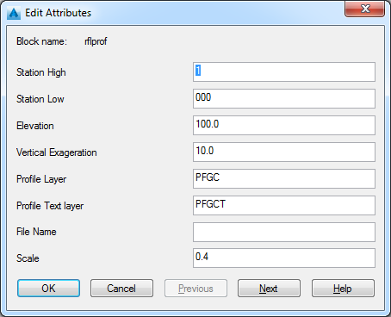

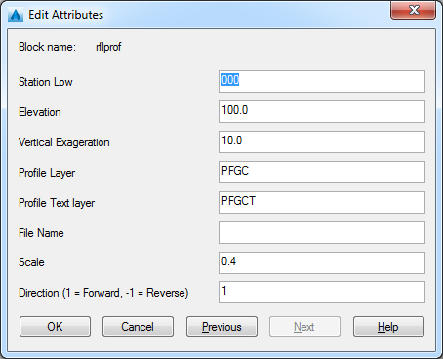

Station is broken into two parts (for labelling presentation) and is hard coded to be 3 digits after the ‘+’. All information is referenced to the insertion point of the block which is at the center of the ¾ circle. ‘File Name’ is legacy and not used. Scale is a legacy relative value for drawing (I find 0.4 is generally good when drawing at 1:500). Direction is 1 for left to right and -1 for right to left.

I’m currently reworking the code around this block – it was created many years ago. You will need to play with it and get comfortable with how it works.

With the block in place and the values set you can draw profile tangents with simple AutoCAD lines. The elevation and chainage of the line endpoints are defined by the parameters in the profile block.

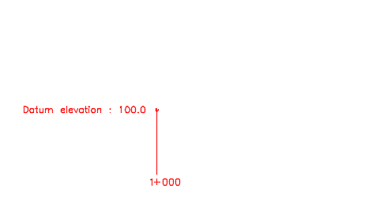

With the block inserted into the drawing (and attributes set) you will need to let the programs know how the grid is situated. To do this enter ‘(RFL:PROFDEF)’ at the command prompt



If only one of the blocks exist in the drawing you will not be prompted to select anything – if more than one exist you will be asked to select which one you currently wish to use. If you do not see the list of variables and values something went wrong – check your block and try again.

You can now start drawing your profile lines. Profile lines are simply AutoCAD lines. If you have specific station/elevation locations you want to use there is a command ‘(RFL:VP)’ which will assist. Start your line command and then enter ‘(RFL:VP)’ at the command prompt

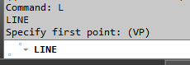

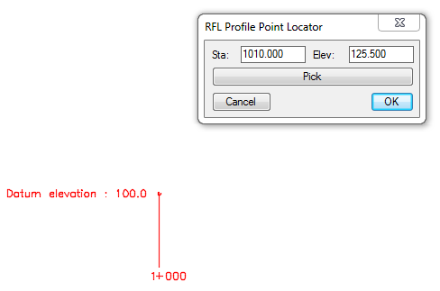

Pressing ‘OK’ will place a point at the station and elevation specified

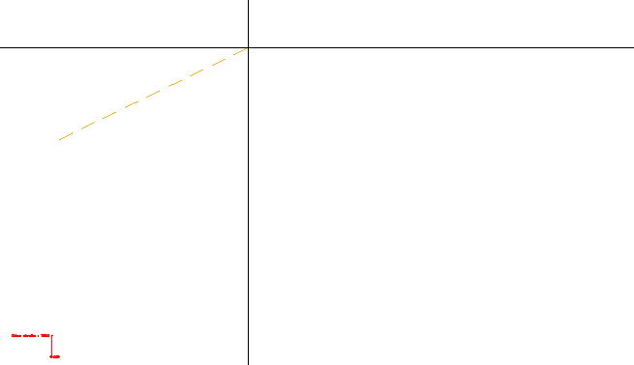

Continue drawing a few more lines

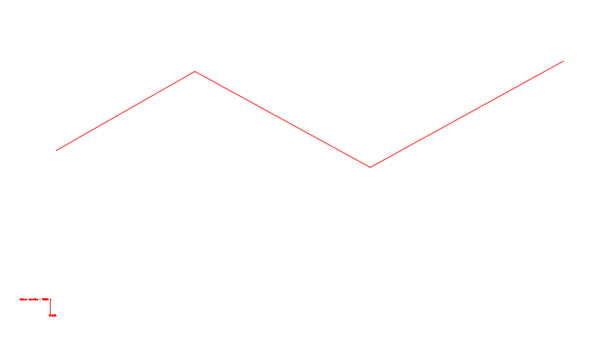

We can now start drawing vertical curves. To do so enter ‘VCURVE’ at the command prompt. You will be prompted to select the left and right tangents (note that you must select left and right regardless of which direction the profile has been defined)

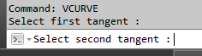

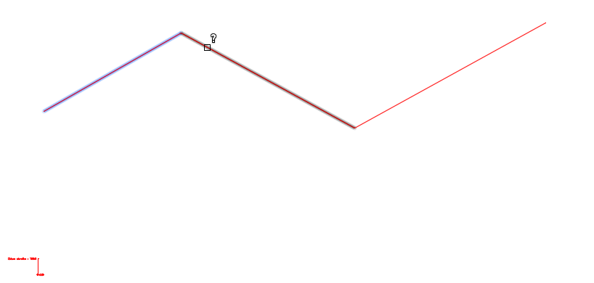

Now enter the vertical exaggeration. Note this value always defaults to 10.0, the reason for this is that you do not need a profile block defined to draw a vertical curve and only require two lines (it should become apparent why this is useful in future lessons).

The program will now cycle through definition values, ‘L’, ‘K’ and ‘Through Point’. For my profile I will use 200.0 – you can experiment with values and which parameters to use. If you don’t like what you’ve drawn/created then simply erase the vertical curve and PVI block.

Once you have your vertical curves defined you need to put a zero length PVI block at the beginning and end. The reason for this is that the profile is defined by these PVI blocks and not the linework between them. Profiles must always begin and end with a zero length block. To do this copy one of the blocks to the endpoint and edit it’s attributes (‘K’ and ‘L’) to be 0.0

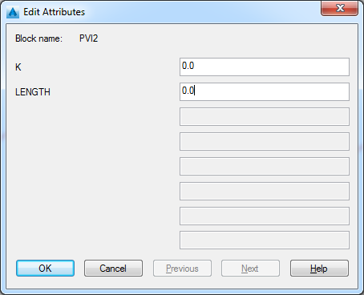

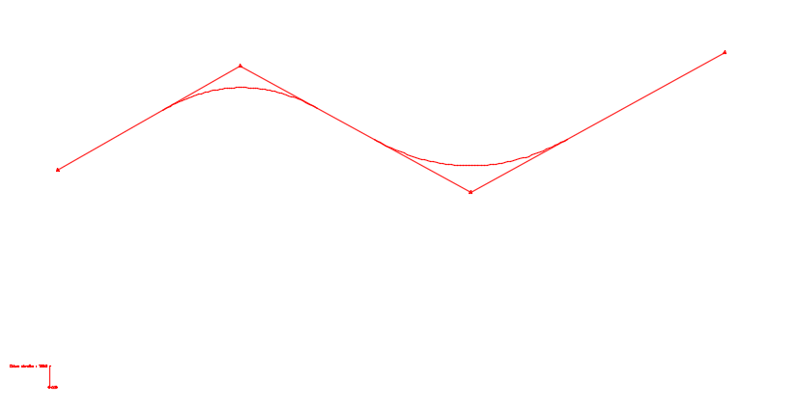

Your profile linework should now be complete so you can get the profile into memory. Enter GPROF (GetPROFile). If you have more than one profile block you will first be asked to select which one you want to use. You will then be asked to select the PVI blocks. You don’t need to worry about selecting more than the blocks – GPROF will only use the PVI blocks within your selection. Also, if you know for sure that all the PVI blocks for the given profile are on the layer specified in the profile definition block then you can simply hit return. I generally select them manually – the reasons will become more apparent when you have many profiles defined (drawn).

To check that everything went well, erase the profile entities and redraw the profile. To draw the profile use the command DPROF (DrawPROFile). If more than one definition block exists you will first be asked to select the desired one. Enter ‘Yes’ to draw the profile, enter ‘No’ to not delete existing entities (this can be useful but dangerous – it will erase everything on the layer specified in the definition block) and finally ‘Yes’ or ‘No’ to draw circles at the high/low points (I generally enter ‘No’).

If you see the profile as before (except that the tangents will start/stop at vertical curve points) then everything went well, if not undo until you have your linework back and try again. Note that I find it useful to issue ‘UNDO’ ‘MARK’ to place mark points – you can then issue ‘UNDO’ ‘BACK’ to get to specific points.

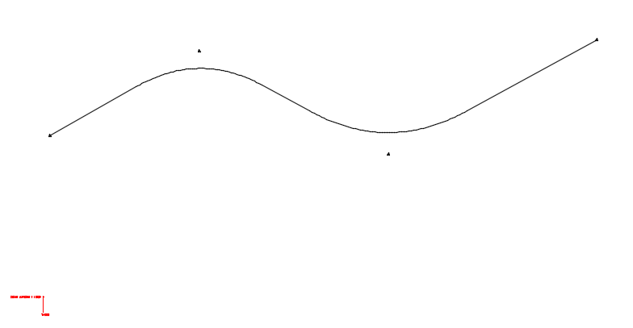

With the profile in memory we can now store it in the alignment block that was placed in the ‘Horizontal Control’ section above. Do this by entering the command WPROFB (WritePROFileBlock) and select the alignment block

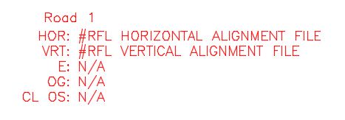

Now do the same for the 2nd profile definition. Note that the elevations must match at their crossing point – looking ahead at ‘1.3 Querying Points’ may provide some insight on some useful tools

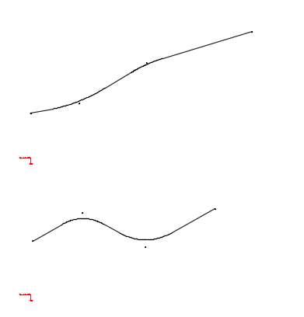

* 1. Querying Points

Commands Used:

* RAB
* RNE
* (RFL:PROFDEF)
* VPL

Make sure you have your correct alignment loaded into memory. RAB (ReadAlignmentBlock) is your friend for selecting the desired alignment

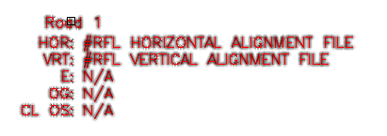

Once you have the desired alignment you can query a location by using RNE (ReportNorthingEasting) and then selecting the desired point. In my example I will snap to the intersection between the two alignments

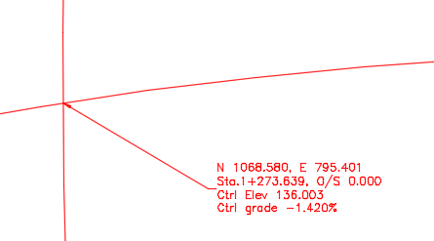

The command will report the Northing/Easting, Station/Offset (if the point is valid with respect to the alignment in memory), the control Elevation and Grade (if the station is valid with respect to the profile in memory) and the left/right superelevation (see later in this lesson and again if valid with respect to the superelevation in memory).

Now use RAB and select the second alignment

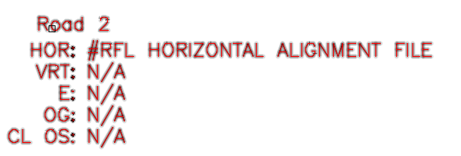

The use RNE again at the same point used above

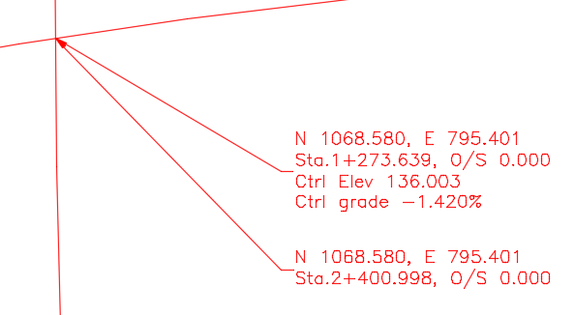

This provides some very useful information. If this is to be an intersection the second alignment must cross the first at the elevation of the first. I.e. at Sta. 2+400.998, Road 2 must be at elevation 136.003. This will assist in creating the profile for Road 2.

Similar to RNE, VPL (VerticalPointLabel) is used for labeling points along a profile

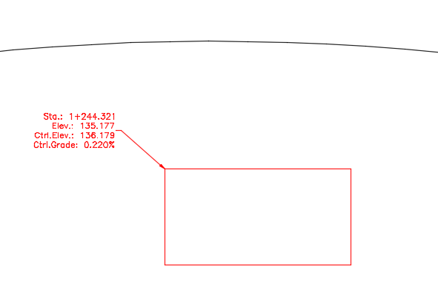

Note that you must ensure you have the correct profile in memory, ‘RAB’, and the correct profile grid defined, ‘(RFL:PROFDEF)’.

* 1. Superelevations

Commands Used:

* MAKEENT
* GSUPER
* WSUPERB
* DSUPER
* RAB

Superelevations are defined by placing ‘SUPER’ blocks along the alignment. If ‘SUPER’ is not defined in the drawing it can be created via MAKEENT

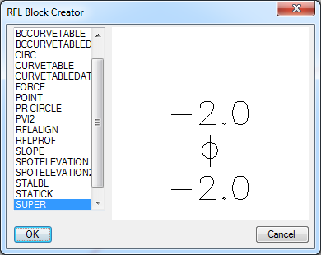

This is a simple block with two attributes, ‘LEFT’ and ‘RIGHT’, both in ‘%’ with up positive and down negative. Note: the block also has a ‘POINT’ entity – I find it useful to change your ‘PDMODE’ to 34 and ‘PDSIZE’ to 0.25. Insert these at all the key locations along your alignment

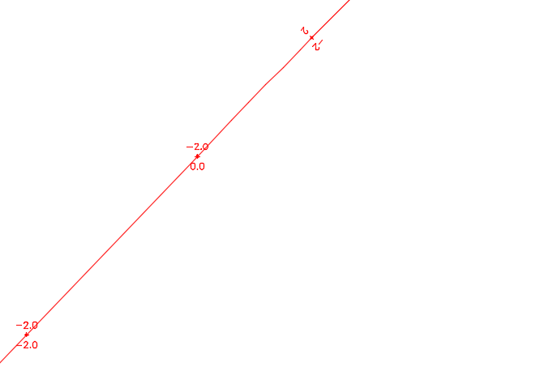

Once all have been placed, use GSUPER (GetSUPERelevation) to load into memory. Note: I find it useful to select one block and then right-click to select similar – with all the blocks selected enter GSUPER. Nothing is preventing from just windowing all the blocks (‘GSUPER’ will only use the ‘SUPER’ blocks) – it is easier to erase using ‘PREVIOUS’ after GSUPER has completed.

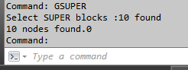

GSUPER will report how many blocks were found. You can confirm that they were read correctly by erasing the blocks then drawing them back with DSUPER (DrawSUPERelevation)

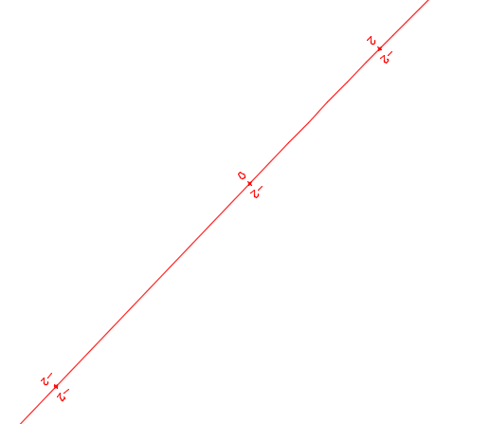

DSUPER will also reorient the SUPER blocks to the current alignment.

Once you’ve confirmed that they are where you need them to be use WSUPERB (WriteSUPERelevationBlock) to store them in the alignment block

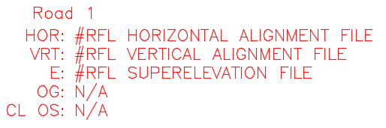

Once stored in your alignment block I usually delete them from the drawing – this assists in creating superelevations on other alignments.

In my example there are 10 superelevation points along ‘Road 1’ (Start, Runout before TS, TS, Spiral 2/-2 point, SC, CS, Spiral 2/-2 point, ST, Runout after TS, and End) and 2 superelevation points along ‘Road 2’ (BC and EC).

With all the details loaded RNE now shows even more information

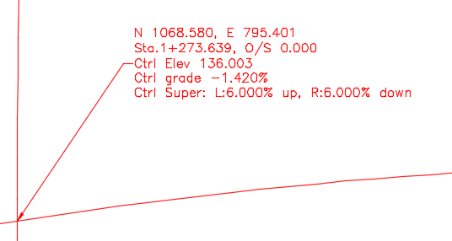

* 1. Spot Elevations

Commands Used:

* MAKEENT
* SELEV

Spot elevations are simple blocks (SPOTELEVATION and SPOTELEVATION2) containing a single AutoCAD point and single ‘ELEV’ attribute (note I have two, one with the attribute above the point and one below – you can create any block you wish so long as there is only one attribute, ‘ELEV’, within it). If the elevation block does not exist in the drawing use MAKEENT to create it

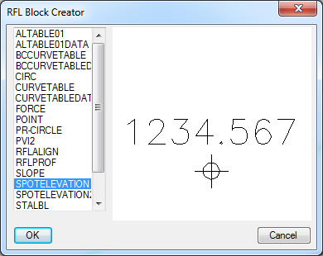

Always make sure you have one of your desired elevation blocks in the drawing – many tools will ask you to select your desired block prior to executing (subsequent uses will use the previously selected block – this will be reset if the drawing is closed and reopened). For my example I have created a very simple intersection – the control lines have been offset 11m left and right, a corner of radius 60m was placed and corner lane widths set at 6m

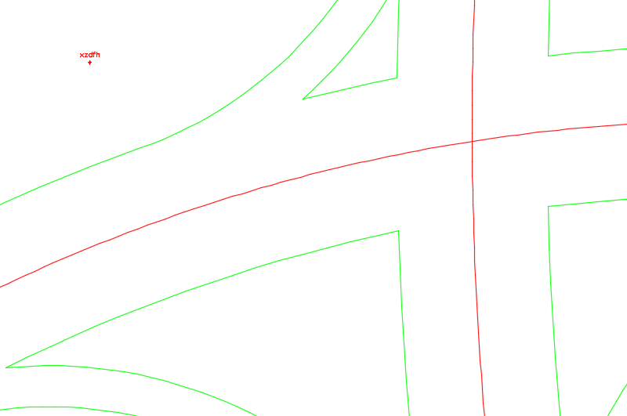

SELEV (SpotELEVation) is a tool for placing elevation blocks along an alignment. It will use the currently defined alignment, profile and superelevation (superelevation is optional but useful) to calculate the elevation of the point selected and then insert the block with its attribute set to that calculated value. Enter SELEV at the command prompt, if you have the superelevation loaded it will ask if you want to use it (note that the default is ‘No’). It will then ask the offset from centerline where the profile control is (generally 0.000 but many location use a median curb for profile control). Next select the desired block (the one you inserted or one already used)

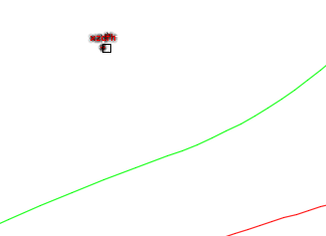

Enter a delta elevation (generally 0.000 – this value will be added/subtracted from each elevation). And finally the rotation direction (generally ‘Forward’ – this is for presentation). Now snap to key points along the alignment

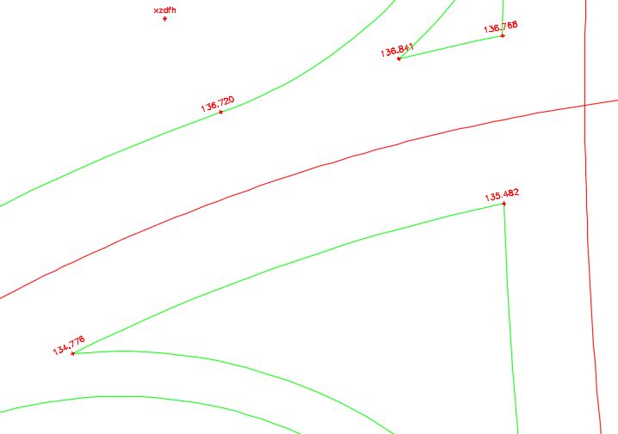

Note: that first elevation block can be erased as you now have many others within the drawing.

* 1. XY Point (RFL:XYP)

Commands Used:

* (RFL:XYP)

(RFL:XYP) is a useful tool (either nested within an AutoCAD command or for drawing section lines) for specifying points on a drawing that reference the current alignment.

* + 1. Specifying a Single Alignment Point

In my example I have labelled a point (using RNE) at the end of the SB to WB ramp along ‘Road 1’

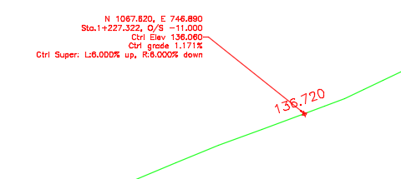

Say I want to draw a line from this point to a point on the other side at an offset of 7.4 from the control line. To do this start the line command and select the starting point

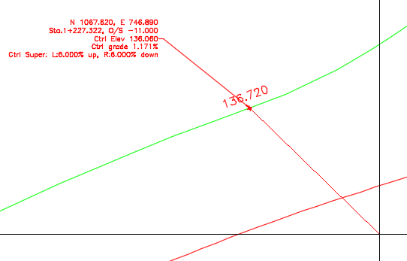

Once the line has started enter ‘(RFL:XYP)’ at the command prompt. This will pull up a dialog box where you can enter your desired station and offset in the ‘Draw single-point’ section

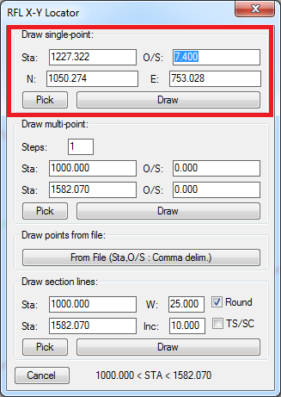

Press ‘Draw’ to draw the computed point on your drawing

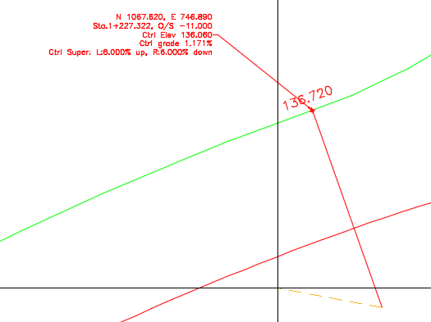

* + 1. Specifying Multiple Points

Say you would like to draw a linear tapering line between two points along an alignment (such as a lane drop). Start a ‘PLINE’ then enter ‘(RFL:XYP) at the command prompt

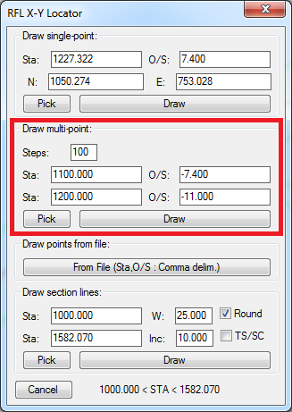

In this example I will draw 100 points starting at Station 1100.0, Offset -7.4 and stop at Station 1200.0, Offset -11.0. Press ‘Draw’ to enter the points into the PLINE command

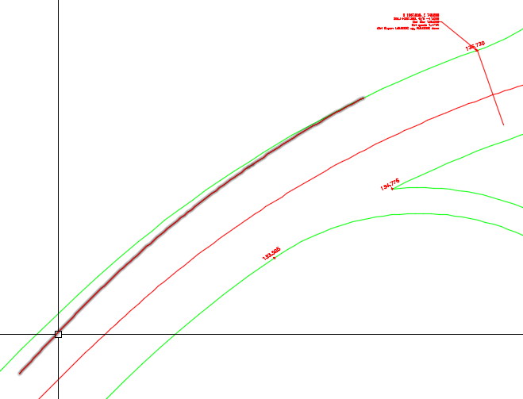

* + 1. Cross Section Lines

Another useful feature of the ‘(RFL:XYP)’ tool is generating cross section lines. For these I tend to draw on either ‘Defpoints’ or some other non-plot layer. At the command prompt enter ‘(RFL:XYP)’ (note section line are not nested within another command). Use ‘Pick’ to select two points (or set the start and end station if you know them). Set ‘Width’ to 0.0 for creating XLINE entities

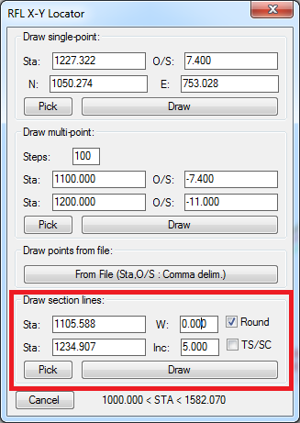

Selecting ‘Round’ will round off to even ‘Inc’ stations. Selecting ‘TS/SC’ will draw additional lines at the node points between the two stations selected.

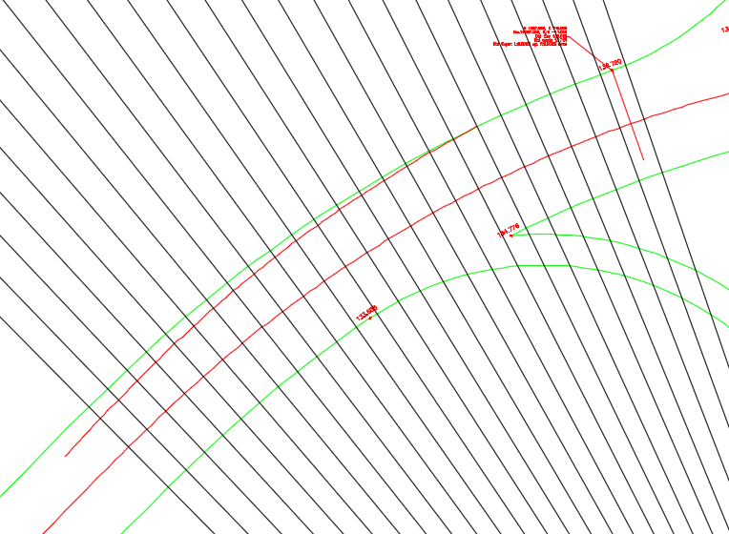

1. Corner Alignments
   1. Define Corner Alignments

Using ‘1.1 Horizontal Control’ define alignments for your ramp/corner geometries

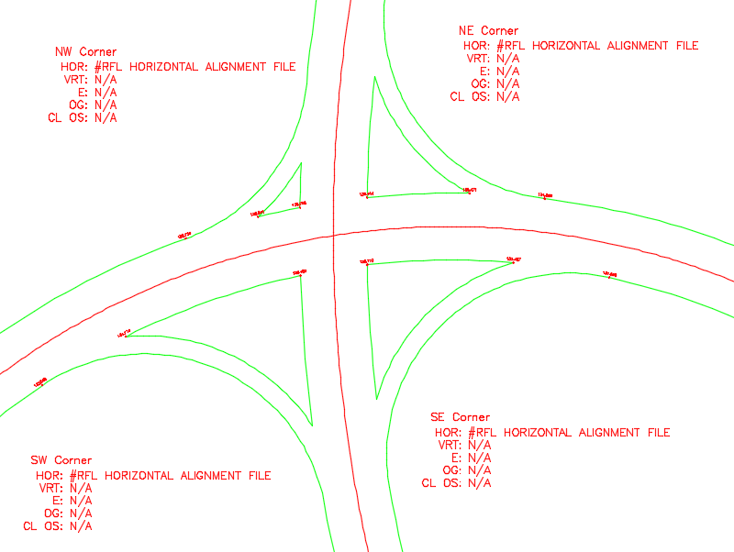

* 1. Draw Cross Section Lines

Note: once completed for ‘Road 1’ repeat for ‘Road 2’

Set alignment/profile/superelevation for ‘Road 1’ using RAB

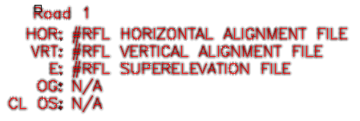

Use ‘(RFL:XYP)’ to create section lines over the required range (for my example I will draw at 5m increment and draw lines at 50m swath)

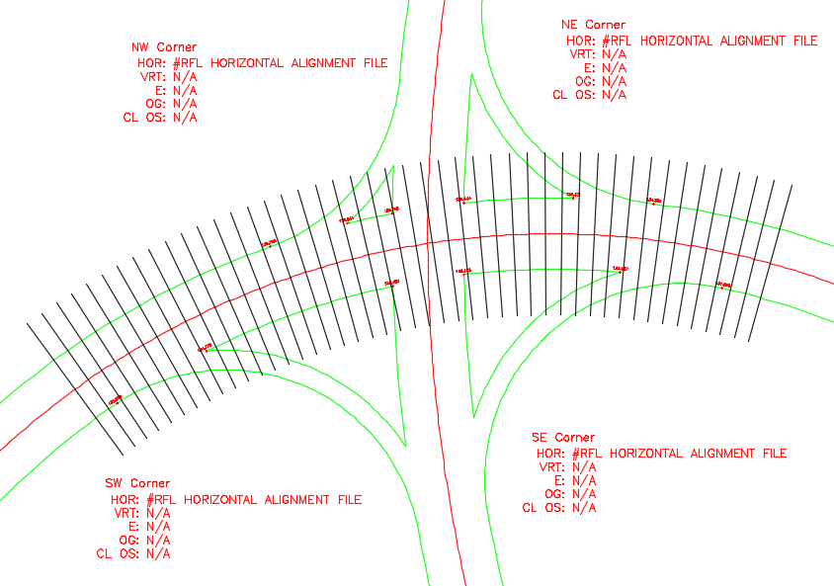

* 1. Insert Elevation Points

Use ‘SELEV’ to place elevation markers along corner alignments next to ‘Road 1’ (note: I find it useful to set your osnap to include ‘Intersection’)

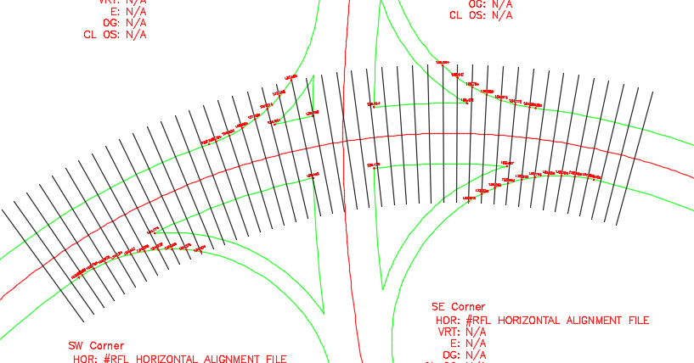

* 1. Repeat for Road 2

Make sure you run ‘RAB’ for ‘Road 2’

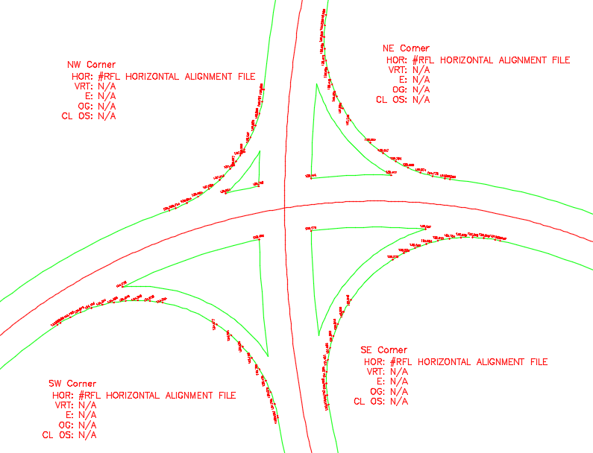

I’ve erased the section lines as they are no longer needed.

* 1. Set Up Profile for Corners

Copy the profile definition blocks to a desired location and update the parameters according to the respective corner alignment. For my example I’ve started all the corners at station 0.0 and defined them in the direction of ‘Road 1’

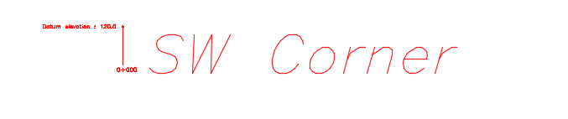

* 1. Draw Spots from Plan to Profile

Commands Used:

* ALIGN2PROF

Set the corner alignment using ‘RAB’

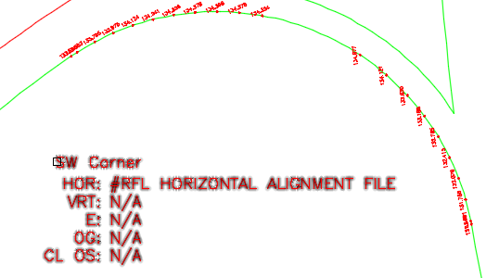

Set the corner profile definition using ‘(RFL:PROFDEF)’

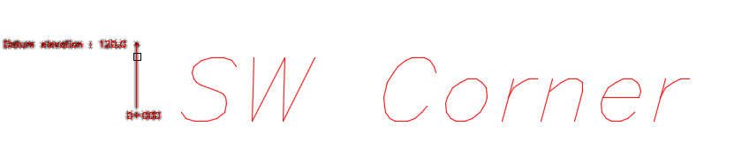

Now you can plot the elevations along the corner alignment onto the profile using ALIGN2PROF (note: I generally plot these lines on ‘Defpoints’ or a no-plot layer and leave them on the profile – these will become a ‘Target’ line when we create the corner profile). Enter ‘ALIGN2PROF’ at the command prompt and select the blocks one by one (note: I generally execute once for each road alignment – this will create two target lines on the profile)

Note: Sometimes you will get a warning message about a selected point not being on the alignment

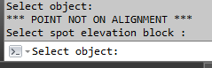

This is a round off error when a point is snapped exactly at an endpoint of the alignment. Either move the point a fraction of a millimeter within the alignment or disregard (this is a design judgement call).

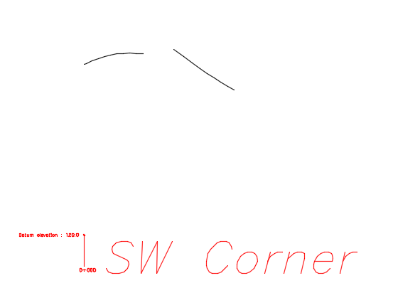

Note: ALIGN2PROF will create individual line segments – I generally PEDIT them to two polylines.

* 1. Best Fit Profile

Using what was learned in ‘1.2 Profile Control’ above best fit profile geometry to the two target polylines.

* + 1. Bonus Tools

A couple of bonus tools that are useful at this stage are:

* BESTVCURVE
* VCDTAN

BESTVCURVE will best fit a vertical curve onto a polyline. Enter ‘BESTVCURVE’ at the command prompt and then select the target polyline. You can select two points along the polyline (useful for very long polylines) or press ‘return’ to best fit the entire polyline. For each of these I will use the entire polyline

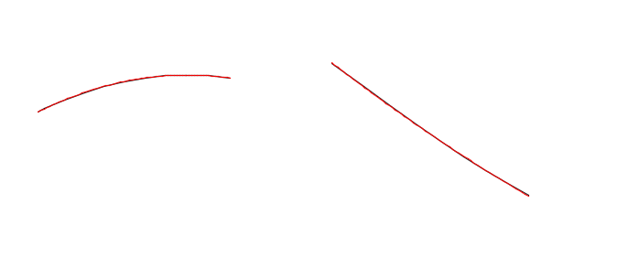

VCDTAN is a utility to draw tangents dynamically off of a vertical curve. Enter ‘VCDTAN’ at the command prompt. You will be asked for the vertical exaggeration, note that the default is 10.0. Next you will be prompted for a slope rounding value – this will round off the slope drawn to the value entered (I usually use the default of 0.100 or pick a value smaller – designer preference and depends on the situation). Pick a point away from the selected vertical curve and a tangent will be drawn

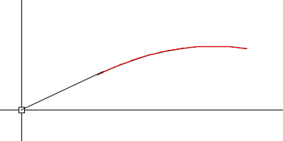

Once the tangents are drawn erase the (temporary) vertical curves, fillet the tangents to form PIs and then use VCURVE to recreate the final vertical curves (use ‘through point’). Finally, add the zero PVIs and define the profile

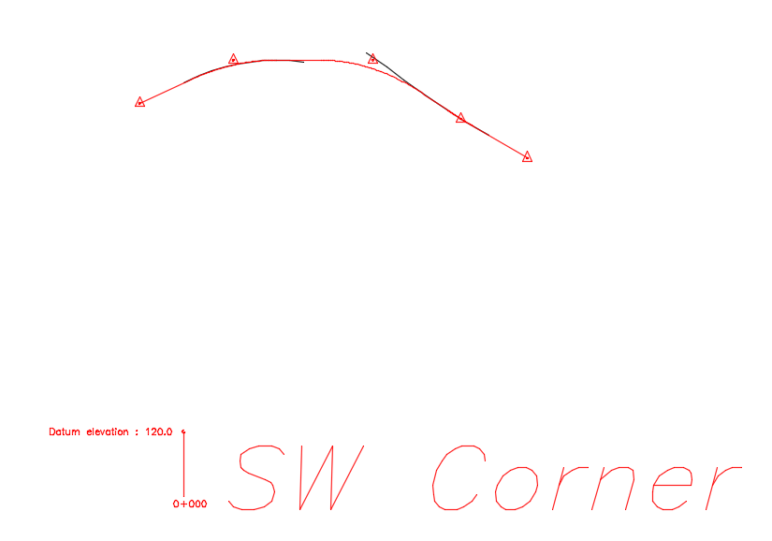

Use GPROF (GetPROFile) to define the profile into memory and WPROFB (WritePROFileBlock) at add it to the corner alignment block

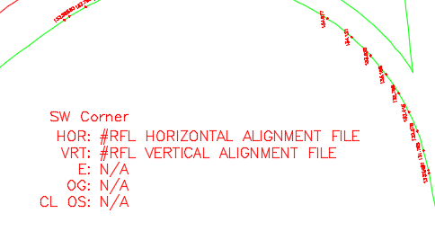

Now repeat for each of the other corners.

* + 1. More Bonus: Labeling Vertical Profiles
* BCPROF
* AIPROF

These are two commands that I have created for labelling vertical profiles. BCPROF creates somewhat to the BCMoT standards and AIPROF to the Alberta Infrastructure. Enter either BCPROF or AIPROF at the command prompt (both work similarly – I’ll use BCPROF).

You will first be asked to select a vertical alignment file – you can press cancel to use the one in memory. Next you will be asked to select the desired profile definition block (or not if only one exists in the drawing). Once selected you will see the following dialog:

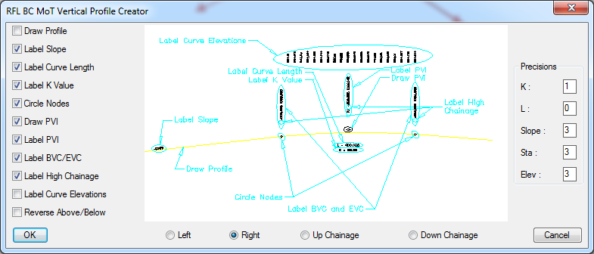

Generally I just use the defaults. Most important is to not draw the profile since it is usually already in the drawing (selecting this will draw the linework but leave out the PVI blocks). The scale of everything is controlled by the ‘Scale’ value set in the profile definition block.

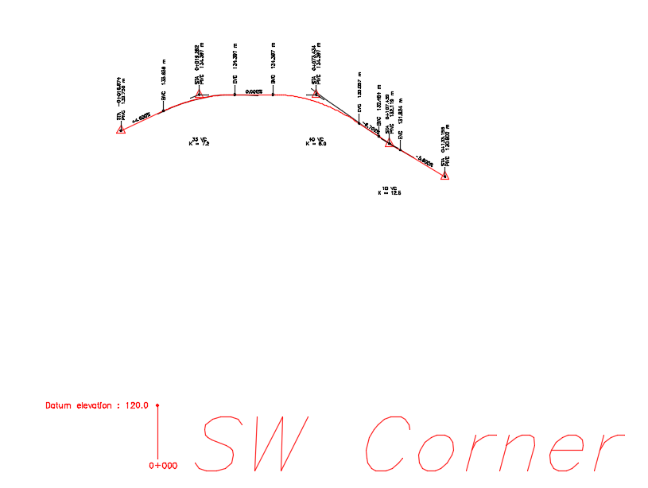

This command takes a bit of practice to get used to. Play with it – change the values… Nothing is permanent as you can always erase or undo.

* + 1. Even More Bonus: Drawing a Grid
* DRAWGRID
* REVGRID
* DEFGRID

Enter DRAWGRID at the command prompt. This will ask you to select a grid definition block – press enter to insert one and then snap to the center of the profile definition block (or it insertion point)

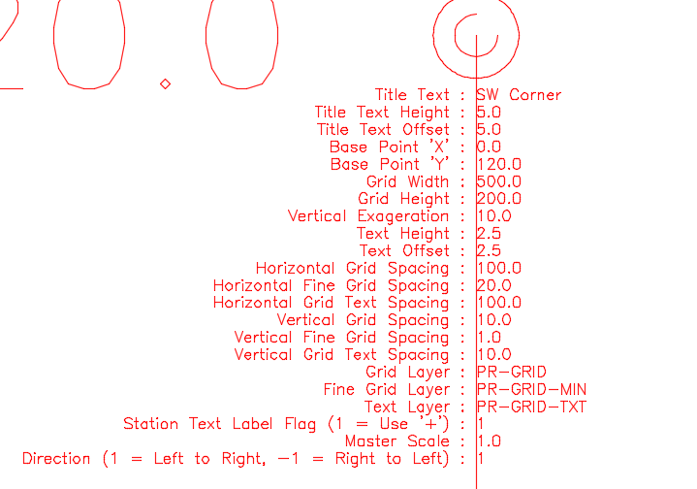

Modify the ‘Title’, ‘Base Point Z’, ‘Base Point Y’, ‘Station Label Flag’ and whatever other values you see fit. Rerun DRAWGRID and select the block (once drawn you can delete the block)

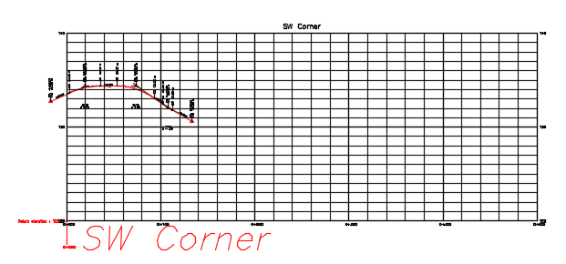

With the block in place you can revise its width and height with REVGRID to place it better around the profile linework (note: do not move it as it will render the grid data incorrect relative to the profile linework). If you don’t like the grid spacing or layers or any other details you can run DEFGRID and select the grid – this will place a new grid definition block on the grid. Erase the grid, revise the block and rerun DRAWGRID. Otherwise:

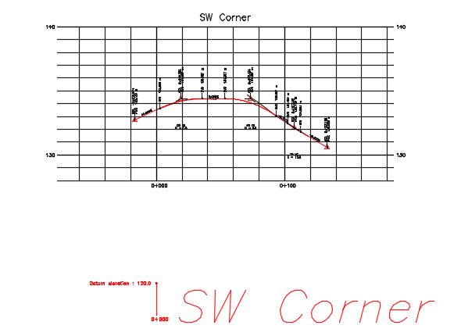

Once it is to your liking you can move it around provided you select the entire grid, linework and profile definition block.